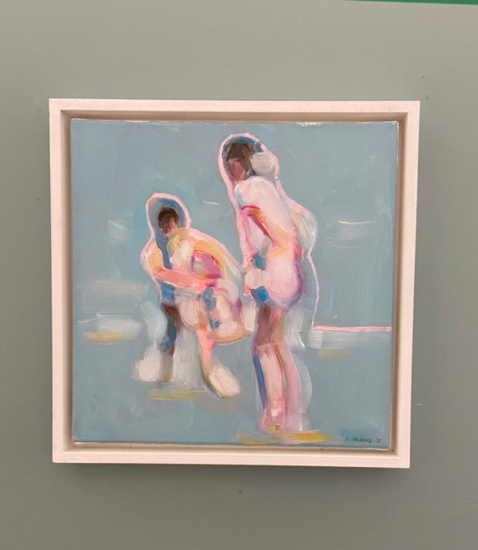
Cooling Down, Oil on Canvas, 34cm x 34cm, (Framed) 2022. €420

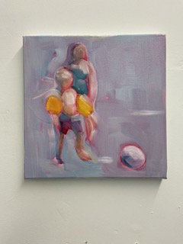
Catch, Oil on Canvas, 30cm x 30cm (unframed) , 2022. €399

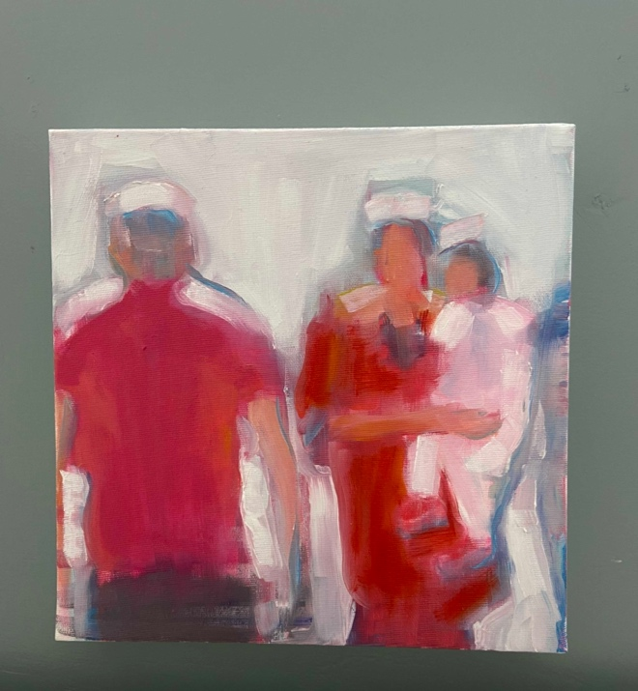
Borrowed from our children. Oil on canvas, 30cm x 30cm, 2022. €400

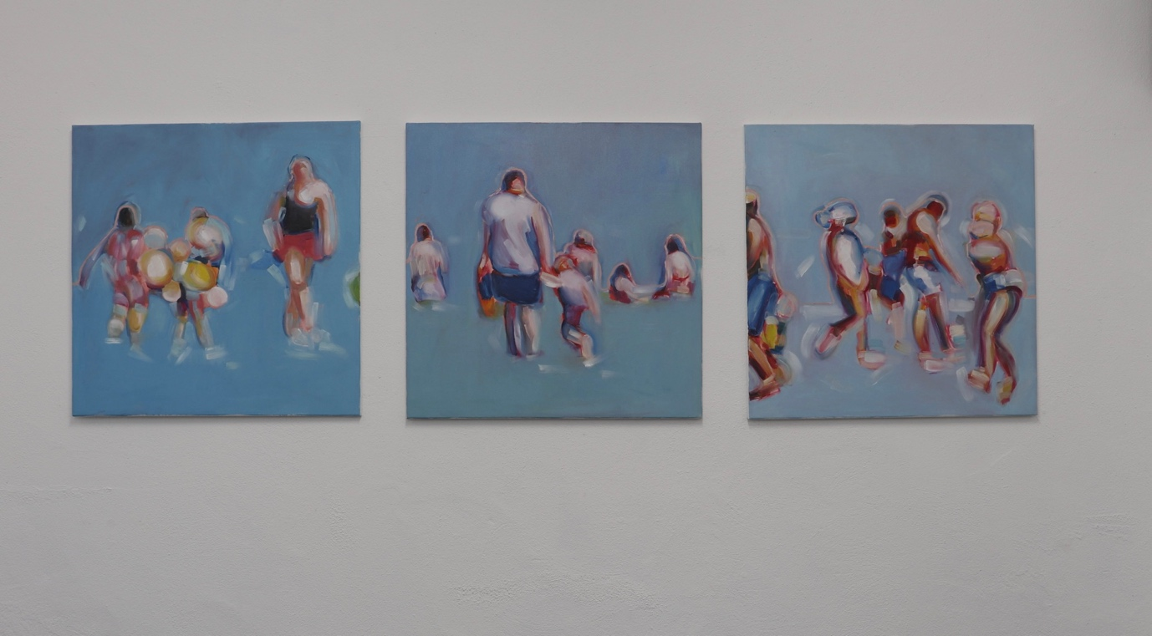
These are all 80cm x 80cm and are €750 each

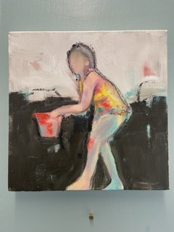
The red bucket, Oil on deep edge canvas, 30cm x 30cm, 2023, (unframed) €400

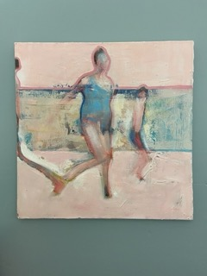
Ice cream Sundays, Oil on canvas, 50cm x 50cm, 2019. (unframed) €480
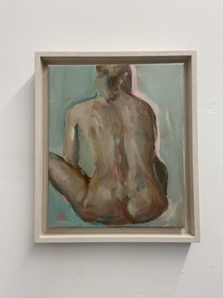
Study for self isolation series, Oil on canvas, 30cm x 25cm, 2021. €300

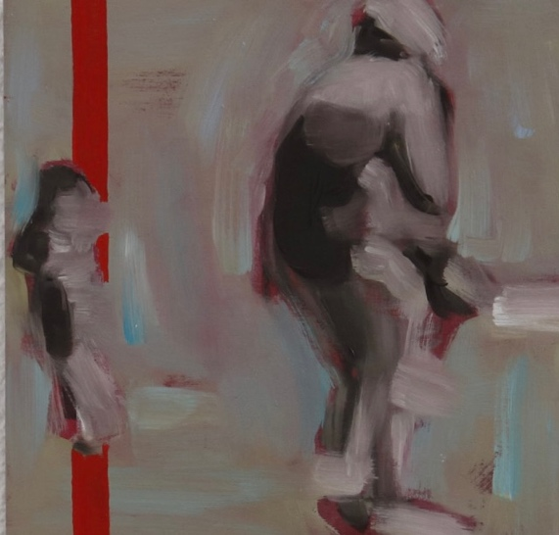
The Beach that used to be. Oil on wood panel, 26cm x 26cm, 2022. Available from the courthouse gallery 26th May – 22nd July

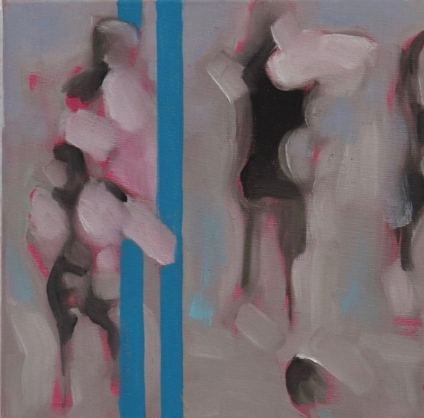
Fuzzy Sundays. Oil on deep edge canvas. 30cm x 30cm (Unframed). 2022.
Available from the courthouse gallery 26th May – 22nd July.

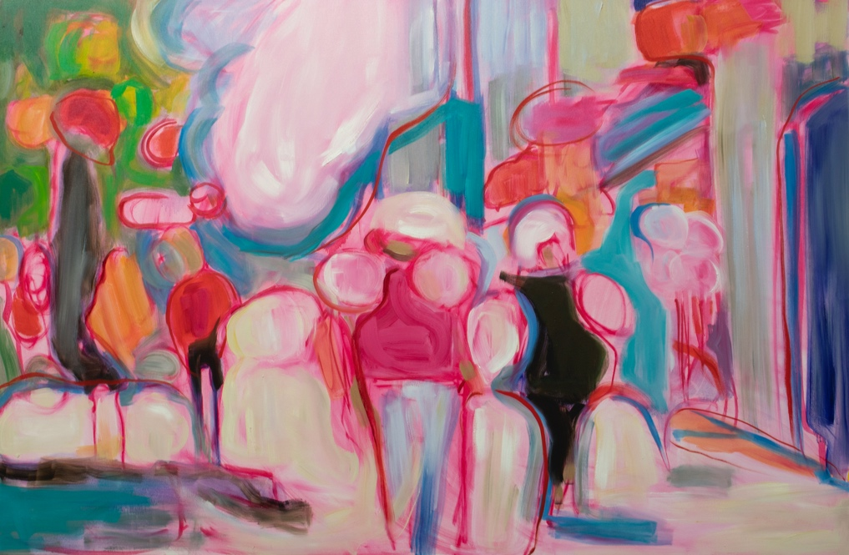
Main Street, Oil on Canvas, 100cm x 150cm, 2022. €1200

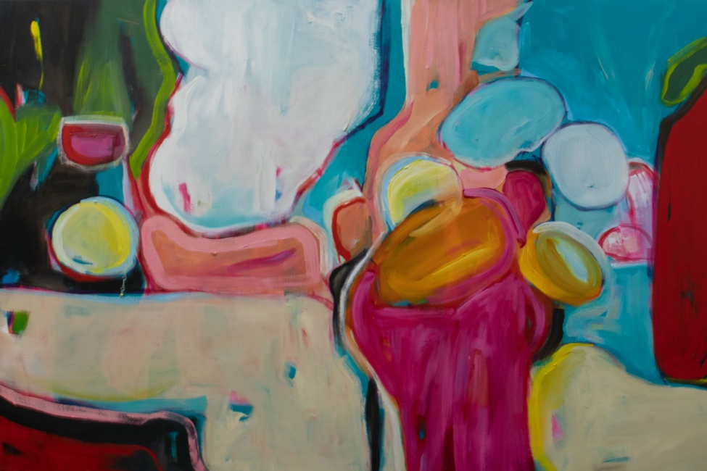
5000 degrees kelvin. Oil on Canvas, 100cm x 150cm, 2022. €1200

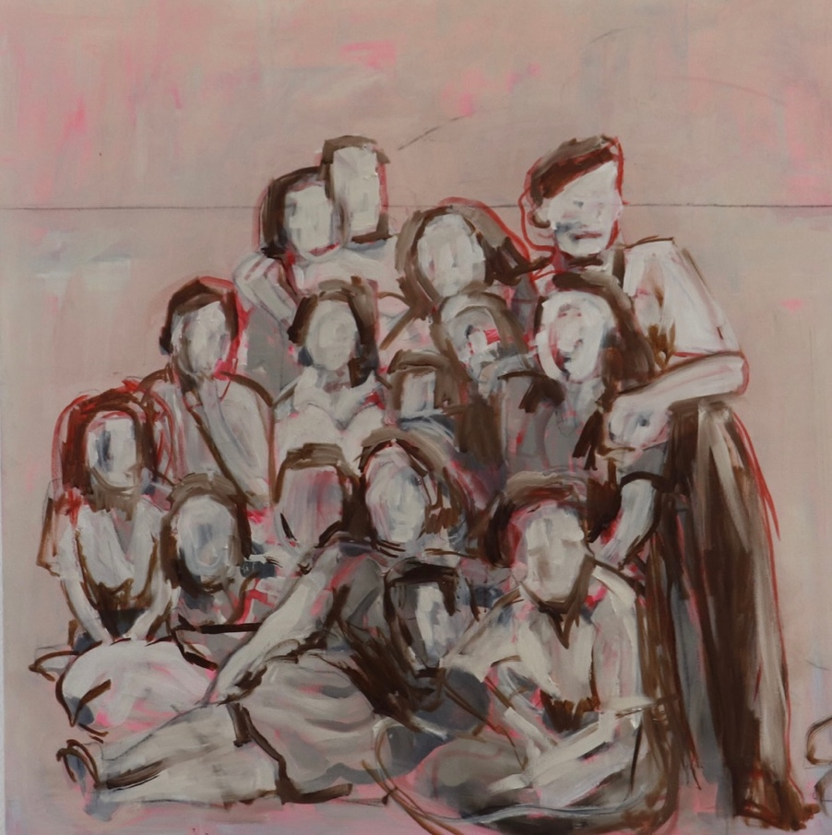
The inner circle II. Oil on canvas, 100cm x 100cm, 2022. €900

I have another few larger pieces completed but not yet varnished. They are approx. 100cm x 170cm.
